NAME: FAIZAN BASHEER

ROLL NO:24K0571

LAB 5 TASK

Q1. Write a C program that performs a left bitwise shift on an integer by a specified number of positions and prints the result.

**SOURCE CODE:**

#include<stdio.h>

int main()

{

int val,shift;

printf("ENTER THE VALUE:");

scanf("%d",&val);

printf("ENTER THE SHIFT:");

scanf("%d",&shift);

printf("LEFT BITWISE SHIFT:%d",val<<shift);

}

**OUTPUT:**

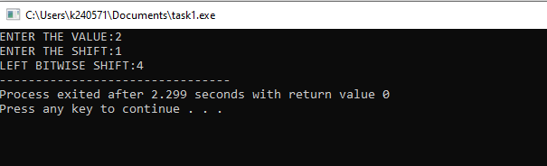

Q2. Write a C program that takes an integer input and determines if it is divisible by both 4 and 6. Additionally, the program should print the remainder when the number is divided by 4 and 6.

**SOURCE CODE:**

#include<stdio.h>

int main()

{

int n;

printf("ENTER A NUMBER:");

scanf("%d",&n);

if(n%4==0 && n%6==0)

printf("%d is divsible by both 4 and 6",n);

else if(n%4!=0)

printf("Remainder when divided by 4 is %d",n%4);

else if(n%6!=0)

printf("Remainder when divided by 6 is %d",n%6);

else

printf("INVALID NUMBER");

}

**OUTPUT:**

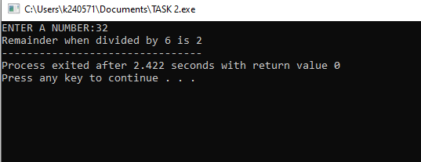

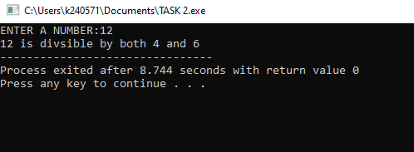

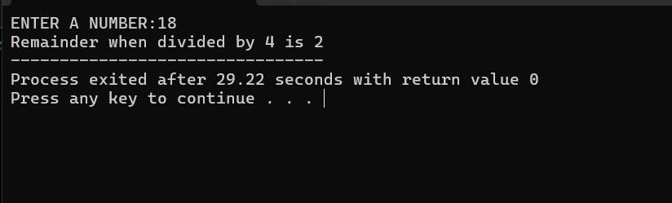

Q3. Write a C program to determine the approval status of a loan application based on the applicant's credit

score, annual income, and existing debt. Use nested if-else if statements with the following criteria:

• Approved: Credit score >= 750, annual income >= 60000, and existing debt < 20000.

• Conditionally Approved: Credit score >= 700, annual income >= 50000, and existing debt <30000.

• Rejected: Credit score < 700 or annual income < 50000 or existing debt >= 30000.

**SOURCE CODE:**

#include<stdio.h>

int main()

{

int crd_sc, an_inc, ext_debt;

printf("ENTER CREDIT SCORE: ");

scanf("%d", &crd_sc);

printf("ENTER ANNUAL INCOME: ");

scanf("%d", &an_inc);

printf("ENTER EXISTING DEBT: ");

scanf("%d", &ext_debt);

if (crd_sc >= 750)

{

if (an_inc >= 60000 && ext_debt < 20000)

printf("APPROVED\n");

else

printf("REJECTED\n");

}

else if (crd_sc >= 700)

{

if (an_inc >= 50000 && ext_debt < 30000)

printf("CONDITIONALLY APPROVED\n");

else

printf("REJECTED\n");

}

else

{

printf("REJECTED\n");

}}

**OUTPUT**

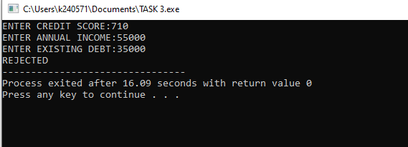

Q4. Write a C program that uses a ternary operator to assign a grade based on a student's score. The grading

criteria are:

• A: Score >= 90

• B: Score >= 80

• C: Score >= 70

• D: Score >= 60

• F: Score < 60

**SOURCE CODE:**

#include<stdio.h>

int main()

{

int score;

char grade;

printf("ENTER YOUR SCORE:");

scanf("%d",&score);

grade = (score >= 90) ? 'A' :

(score >= 80) ? 'B' :

(score >= 70) ? 'C' :

(score >= 60) ? 'D' : 'F';

printf("GRADE IS:%c",grade);

}

**OUTPUT**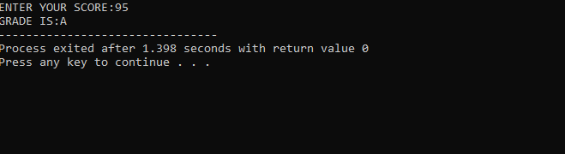

Q5.Write a C program that finds the largest of three given integers using the ternary operator.

**SOURCE CODE**:

#include<stdio.h>

int main()

{

int a,b,c,max;

printf("ENTER 3 NUMBERS:\n");

scanf("%d%d%d",&a,&b,&c);

max = a>b?(a>c?a:c):(b>c?b:c);

a==b&&c?printf("ALL NUMBERS ARE EQUAL"):printf("LARGEST NUMBER IS %d:",max);

}

**OUTPUT:**

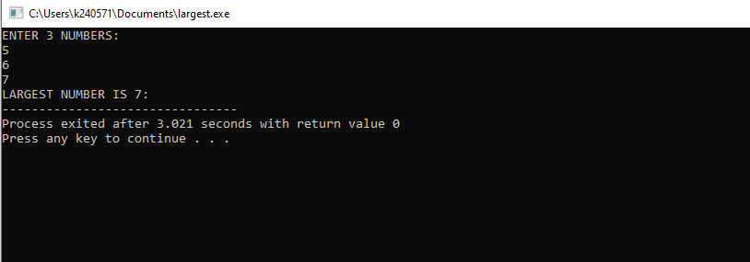

Q6. Write a C program to determine the type of a user’s input based on three criteria: age, membership status, and purchase amount. The program should classify the input into the following categories:

• "VIP Customer" if the person is over 65 years old or if they are a member and have made a purchase over $500.

• "Regular Customer" if the person is not a member but has made a purchase over $100, or if they are under 65 years old and their purchase amount is $100 or less.

• "Guest" if none of the above conditions are met.

**SOURCE CODE:**

#include<stdio.h>

int main()

{

int age;

char mem_status;

float pur_amnt;

printf("ENTER YOUR AGE:\n");

scanf("%d",&age);

printf("ENTER MEMBERSHIP STATUS(Y OR N):");

scanf(" %c",&mem_status);

printf("ENTER PURCHASE AMOUNT:");

scanf("%f",&pur_amnt);

if(age>65 || mem_status=='Y' && pur_amnt>500)

printf("VIP CUSTOMER");

else if((mem_status=='N' && pur_amnt>100 )|| (age<65 &&pur_amnt<=100))

printf("REGULAR CUSTOMER");

else

printf("GUEST");

}

**OUTPUT:**

